Greeting Card Generator Manual

# Introduction: Text

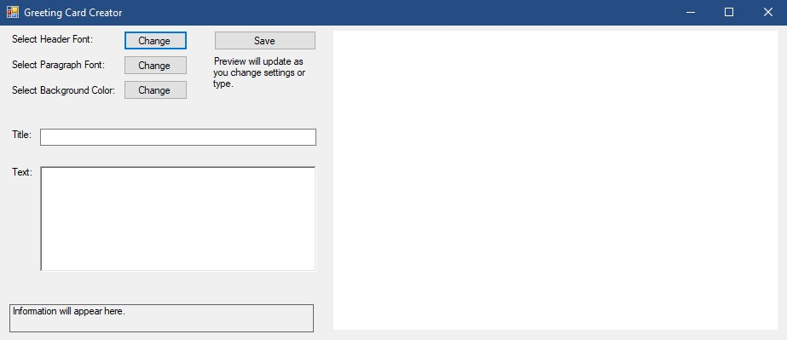

This is the interface for the greeting card creator. To begin, type text into the field labelled: Text. As you do, text will appear on the right-hand side in the preview pane. If no text is typed in, the preview pane will display “Placeholder Text” for the title and paragraph.

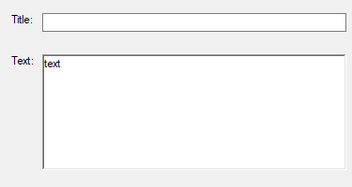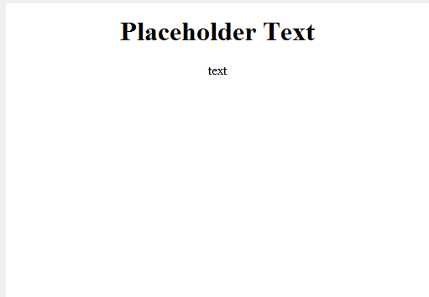

Typing text in the “Title” field will replace the text “Placeholder Text” in the image above.

To move to the next line, or to format your text into paragraphs in the lower “Text” box, press the enter key to add a line break.

To add symbols, on windows 10 and 11, press Windows Key + Period (The “.” key) to open the emojis menu.  
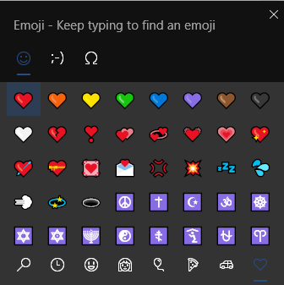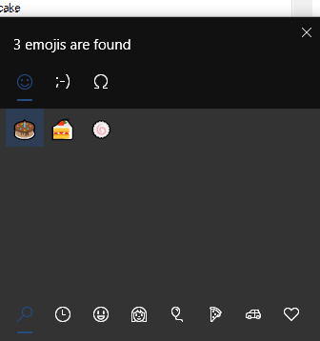

To search for symbols, simply type text.

The emojis displayed will be different depending on your font choice and potentially not render.

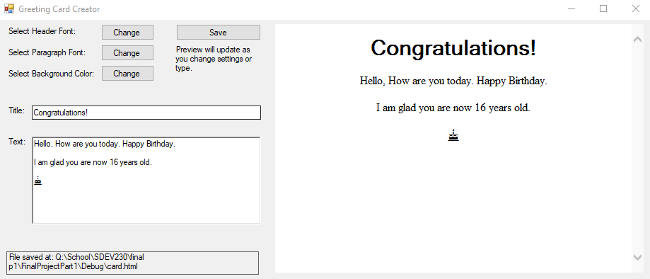

# Fonts

The two buttons in the top left labelled “Select Header Font:” and “Select Paragraph Font:” (pictured above) allow you to change the fonts for the greeting card.

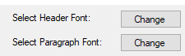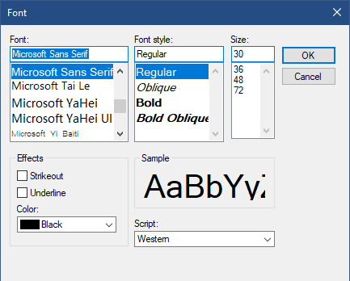

The upper-left box allows you to choose the named font that you want to pick. These fonts vary wildly in style, and you can only have one selected at a time for the header and paragraph separately. Some fonts may not be available among all machines and will display as squares instead of text.

Font-style allows you to choose whether you want the font to be regular, italic, or bold.

Size controls the width in pixels the font will be on the recipient’s screen.

Strikeout and underline allow you to put a line through the text or under the text. This is not recommended.

Color allows you to change the color of the text.

The script box only functions with certain fonts and may only appear depending on your system’s region setting. It changes what language of characters you can type. (Japanese, Korean, Diacritics etc.)

Click the OK button to save your selections. The preview pane will update accordingly. 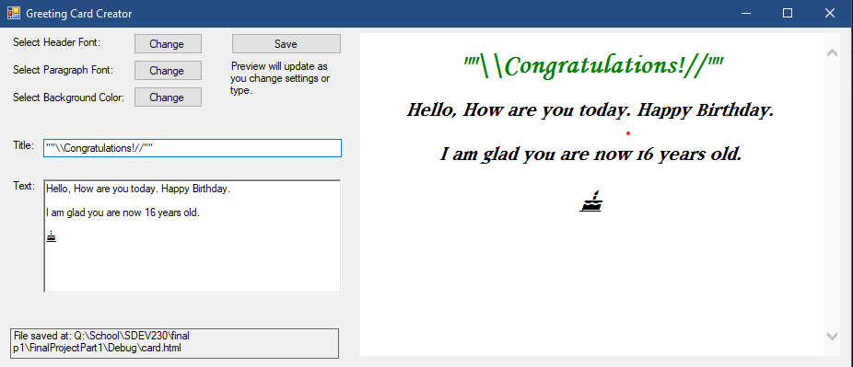

# Background Color



The “Select Background Color:” button allows you to select the color for the background of your card.

Note: Some colors may result in the card being difficult to read.

Clicking the button opens the “Colors” dialogue window.

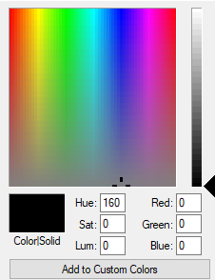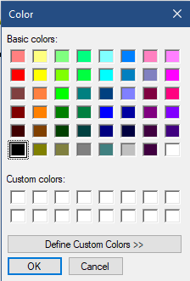

This will allow you to change the colors of the background.

Clicking “Define Custom Colors” will expand the dialog to allow more precise definition of colors.



Drag the bar on the right to adjust the brightness of the color and click on the rainbow to adjust the hue of the color. You may also enter these manually. Click “Add to custom colors” and it will be added to the row of white squares named “Custom colors” displayed above. You may then choose that color to change the background to that color.

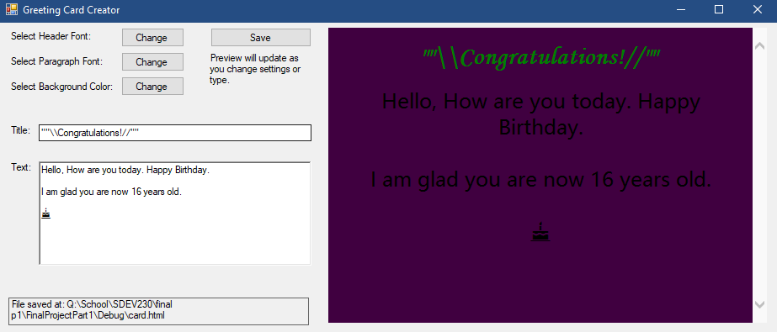

# Saving Your Card



The save button will open the default Windows Save As dialogue Prompt.

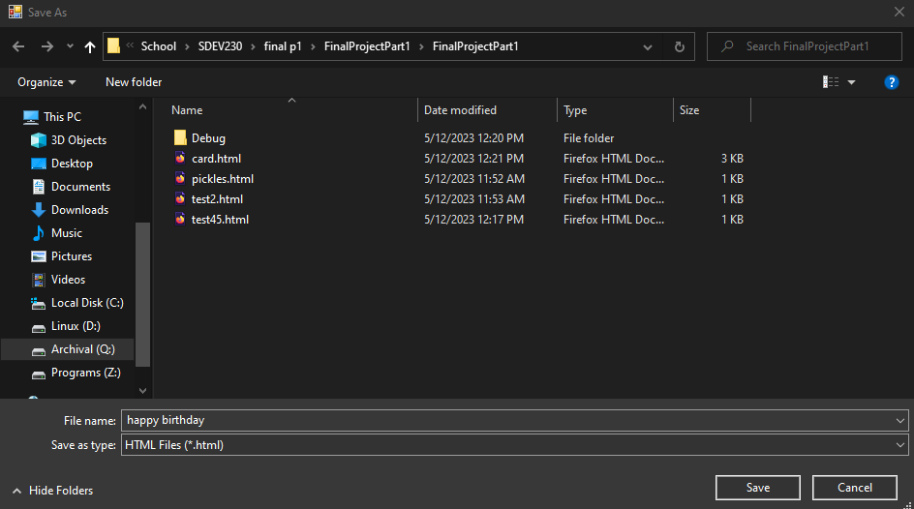

The colors may vary based on your operating system. Enter a name into the “File Name” box and navigate to the folder you wish to save your card in. Then click the save button.

Cards may be opened in any web browser.

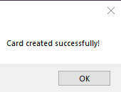

This message will be displayed if the program successfully saved the file. Otherwise, a number of other errors may appear. The issues are most likely hard drive or system related, so this manual cannot give support for those files.

Thank you for using Greeting Card Creator.